**TMA Supplier Packaging Design Approval Form**

|  |  |
| --- | --- |
| Supplier: |  |
| TMA Part Number/Description: |  |
| Supplier Contact: |  |
| Supplier Phone Number: |  |
| Supplier Email: |  |

**Inner Packaging**

Inner pack boxes should consist of a corrugated carton measuring 12” L x 7” W x 5” H

All inner pack boxes must have a 3” x 3” white label placed on one end of the box. The label must contain the following information:

Supplier Name Release Number

Part number (with Barcode) Revision Level

Quantity (with Barcode)

Inner pack boxes not to exceed 35 lbs.

**Outer Packaging**

Outer Packaging should consist of a corrugated carton 30” W x 36” L on a pallet with the same measurement.

Pallet with carton should not exceed 34” High.

Outer carton should have a removable lid.

Carton should be poly strap banded to pallet.

Pallet should be stretch wrapped.

All outer pack cartons must have 4” x 6” white labels on 2 sides of the carton (front and back). The label must contain the following information:

Supplier PO Number Ship Date

Part Number (With Barcode) Revision Level Weight

Description Release Number

Quantity (With Barcode) Packing Slip #

**Packaging Configuration**

**Outer Pack Label**



4” x 6”

**Inner Pack Configuration**

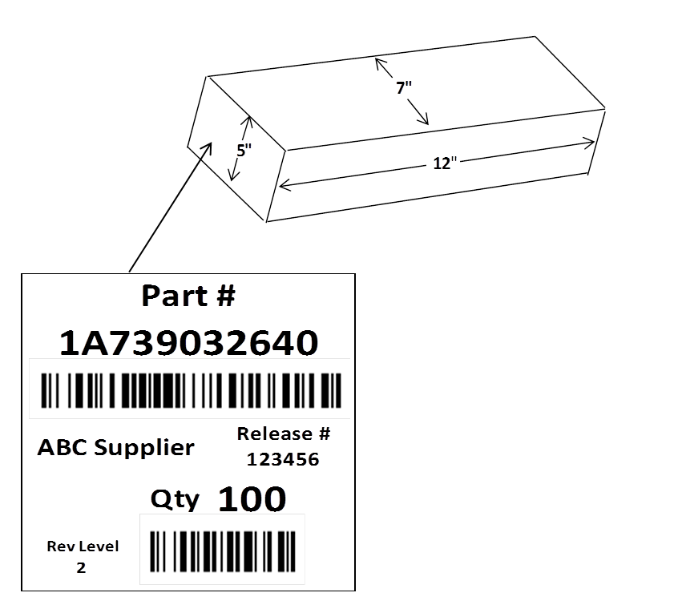

3” x 3”

**Sample Pallet**

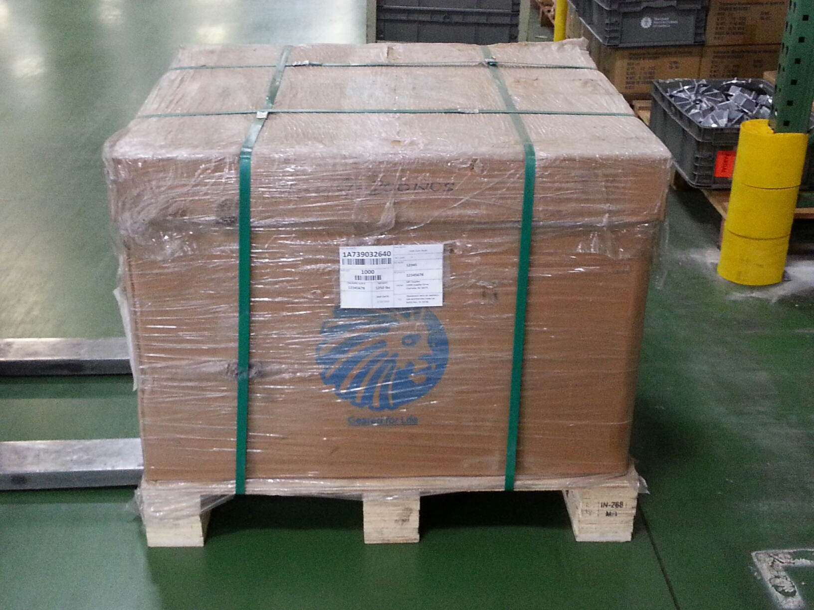

**Pallet Configuration**



**Bulk Packaging**

Bulk Packaging should consist of a corrugated carton measuring 30” W x 36” to 42” L on a pallet with the same measurement.

Pallet with carton should not exceed 34” High.

Bulk Packaging must have 4” x 6” white labels as described above.

**Multiple Parts in One Carton**

Cartons containing multiple part numbers must be clearly marked as: **“Mixed Carton”**

Mixed cartons must have white labels listing all part numbers, descriptions and quantities in the carton. This label must be on 2 sides of the carton.

**Please provide steps for Inner Packaging perseveration. Please include pictures and description.**

**Step: 1 Step: 2 For Step 2, Check All That Apply:**

RP

Type: ______________

Protective Netting

Protective Sleeve

VCI Paper

Other:____________

(Insert Photo of Part with

Protective Packaging; netting,

bag, protective sleeve, etc.)

(Insert Photo of Part only)

Bulk Packaging should consist of a corrugated box measuring 30” W x 36” to 42” L on a pallet with the same measurement.

P

**Description: Description:**

**_____________________ _____________________**

**_____________________ _____________________**

**_____________________ _____________________**

**_____________________ _____________________**

**_____________________ _____________________**

**For step 3,**

**Step: 3 Check All That Apply Step: 4 For step 4, Label Must Contain:**

(Insert Photo of finished Inner Pack Box with Label)

Supplier

Part Number

Quantity

Release Number

Lot Date

Revision Level

Desiccant

Bag/Pack

VCI Bag

VCI Paper

Other_______

(Insert Photo of Part(s)

within Inner Pack Box)

Box Dimensions

Length 12”

Width 7”

Height 5”

Weight can not exceed 35lbs

**Description: Description:**

_____________________ _______________________

_____________________ _______________________

_____________________ _______________________

_____________________ _______________________

_____________________ _______________________

**Please provide steps for Outer Packaging preservation. Please include pictures and description.**

**Step: 5 Check All That Apply for step 5**

Desiccant Bag/Pack

VCI Bag

VCI Paper

(Insert Photo of the contents

inside shipping box)

**Description: ______________________**

**______________________**

**______________________**

**______________________**

**______________________**

**Step: 6 For step 6, labels must contain:**

Supplier Part Number

Part Description

Quantity

PO Number

Lot Date

Release Number

Packing List Number

Revision Level

Ship Date

Weight

**MAX Pallet**

**Height: 34” (0.863m)**

Width**: 48” (1.22m)**

**Length: 48” (1.22m)**

(Insert Photo of

Container/Box)

**NOTE:**

**MAX Pallet**

**Height: 34” (863mm)**

**Width: 30” (762mm)**

**Length: 42” (1066mm)**

Confirm Dimension

Height: ___________

Width: ___________

Length: ___________

**Description:**

**______________________**

**______________________**

__________________________

__________________________

**______________________**

**Additional information for preservation to protect the material during shipment. (Not all parts are applicable)**

**As a Supplier you are still responsible for the protection and preservation of all material shipped to TMA.**

**Suppliers agreed to the statement above. Please sign here and Date DATE**

**TMA Material Flow Coordinator Signature DATE**

**TMA Buyer/Planner Signature DATE**

**TMA Supplier Quality Engineer DATE**

**TMA Logistics Manager Signature DATE**